26th March 2020

Dear Parents/Guardians,
The current unprecedented public health emergency has caused widespread anxiety and stress for our entire community. Our priority at this stage is the health and well-being of everyone. We do not wish to add to the stress and anxiety that currently exists, therefore the home learning activities in each class should be manageable and enjoyable for the children.

Please do not concern yourselves with thoughts such as 'my child will fall behind' or 'my child won't cope next year'. Foley Primary School is a fantastic school and I can 100% assure you that when full time school returns, the brilliant teachers and classroom assistants here will ensure each and every child in our care will continue to fulfil their potential.

In order to facilitate home school learning as best as we can, I have set up a new COVID - 19 page on our school website. Here suggested activities for each class will be uploaded weekly. This will go live on Sunday Afternoon.
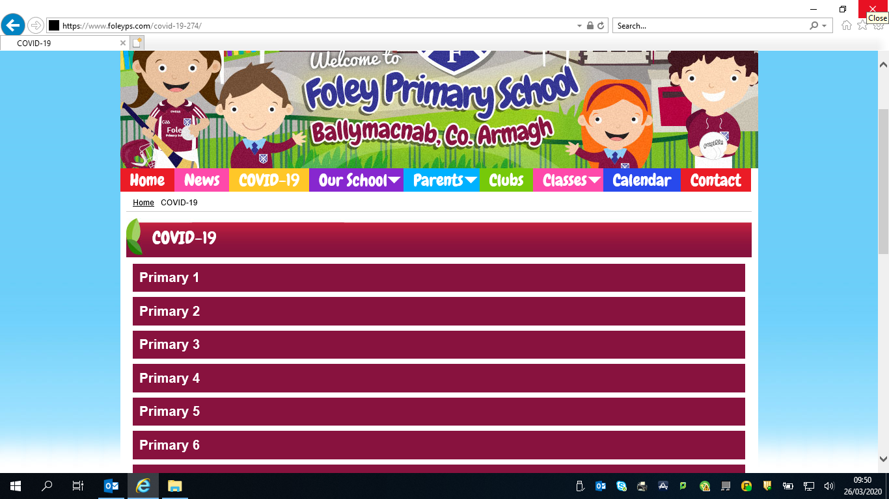

The teachers are working hard at home to prepare tasks for the incoming week, these tasks will be posted in this section of the website. Some tasks will be on

studyladder, some will be practical and some will be written. Please do not feel under pressure to complete all of the tasks which are set, there is no – ‘one size fits all’ in regards to learning from home. Our message is simple: keep reading, writing, spelling, counting and enjoying learning while maintaining physical and mental wellbeing.

If you would like to take a picture of the work that your children complete, or a small video of the ways in which they are keeping busy, please feel free to send them to the school WhatsApp number and I will share them with our community on our ‘School Website and Facebook page’. It is important that during this time we still feel connected to our school community, this will encourage other children as well as celebrate their success and showcase the fantastic work going on in our homes.

If you have any concerns or queries at all, please do not hesitate to contact me and I will do my best to help in any way I can.

Email address: kmccrory179@c2kni.net
WhatsApp: 07857858270

Many Thanks,

Mr McCrory

