Foley Primary School

Covid-19
School Restart Plan
Further Information to Parents
August 2020

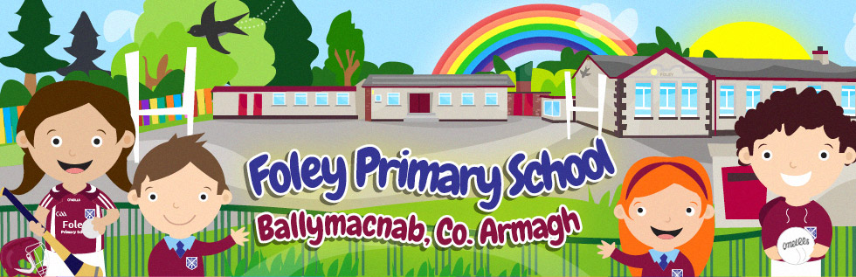

Date: | August 2020

(This Information Pack is written to take into account the guidance from DENI “New School Day – Revised Guidance August 2020”)

Dear Parents

In preparation for the New School Year 2020-21, I wish to provide you with information on the arrangements we have made in following areas; Health and Safety Procedures, Daily Routines, Learning and the Recovery Curriculum as well as the organisation of pupil resources. The arrangements have been shared with staff and our Board of Governors.

This school guidance and reopening plan has been written in line with and after the publication of new school guidance from the Department of Education (NI) August 2020 and reflects how we as school will implement this guidance. The guidance whilst welcome still does not give absolute clarity to schools. As a primary school, due to some of the areas being unclear or ambiguous, we are being left to interpret and implement it as best we can in order to keep all of our stakeholders (pupils, parents, staff and wider school community) as safe as possible.

At Foley Primary School, we understand the importance of children returning to school as soon as it is safe to do so. We know that the children have enjoyed time over recent months with their families and that it may be difficult for some children to, once again, fit in with the new elements of school routine. As a school we will be reopening for children and taking a precautionary and safety first approach and will review how each step is impacting on our entire school community.

As a staff we have been considering the implementation of a ‘Recovery Curriculum’ to support children and their pastoral needs when they return to school. Our recovery curriculum will give the children opportunities to revise literacy and numeracy concepts, to participate in class discussions, to engage in creative lessons which encourage social interaction, as well as extended free time to enable socialisation with children in their class.

As Principal of Foley PS I would ask you to bear with us as we try to implement this guidance in what is an evolving and changeable situation. Everything that we are doing is in an effort to protect and to keep you, your family and our school staff safe.
Kind regards

Kieran McCrory

Covid-19

Symptoms

The main symptoms of Covid-19 are:
- a high temperature – this means you feel hot to touch on your chest or back (you do not need to measure your temperature)
- a new, continuous cough – this means coughing a lot for more than an hour, or 3 or more coughing episodes in 24 hours (if you usually have a cough, it may be worse than usual)
- a loss or change to your sense of smell or taste – this means you've noticed you cannot smell or taste anything, or things smell or taste different to normal

Children and young people who exhibit any symptoms associated with COVID-19 should not attend educational settings. The Department of Health has implemented a contact tracing programme called ‘Test, Trace and Protect’ designed to control the spread of COVID-19.

All pupils are expected to follow the requirements of this programme: to self-isolate if they are identified as close contacts of cases and to obtain a test for COVID-19 if they develop symptoms. All members of their household should follow the appropriate isolation guidance as provided by the Public Health Agency.

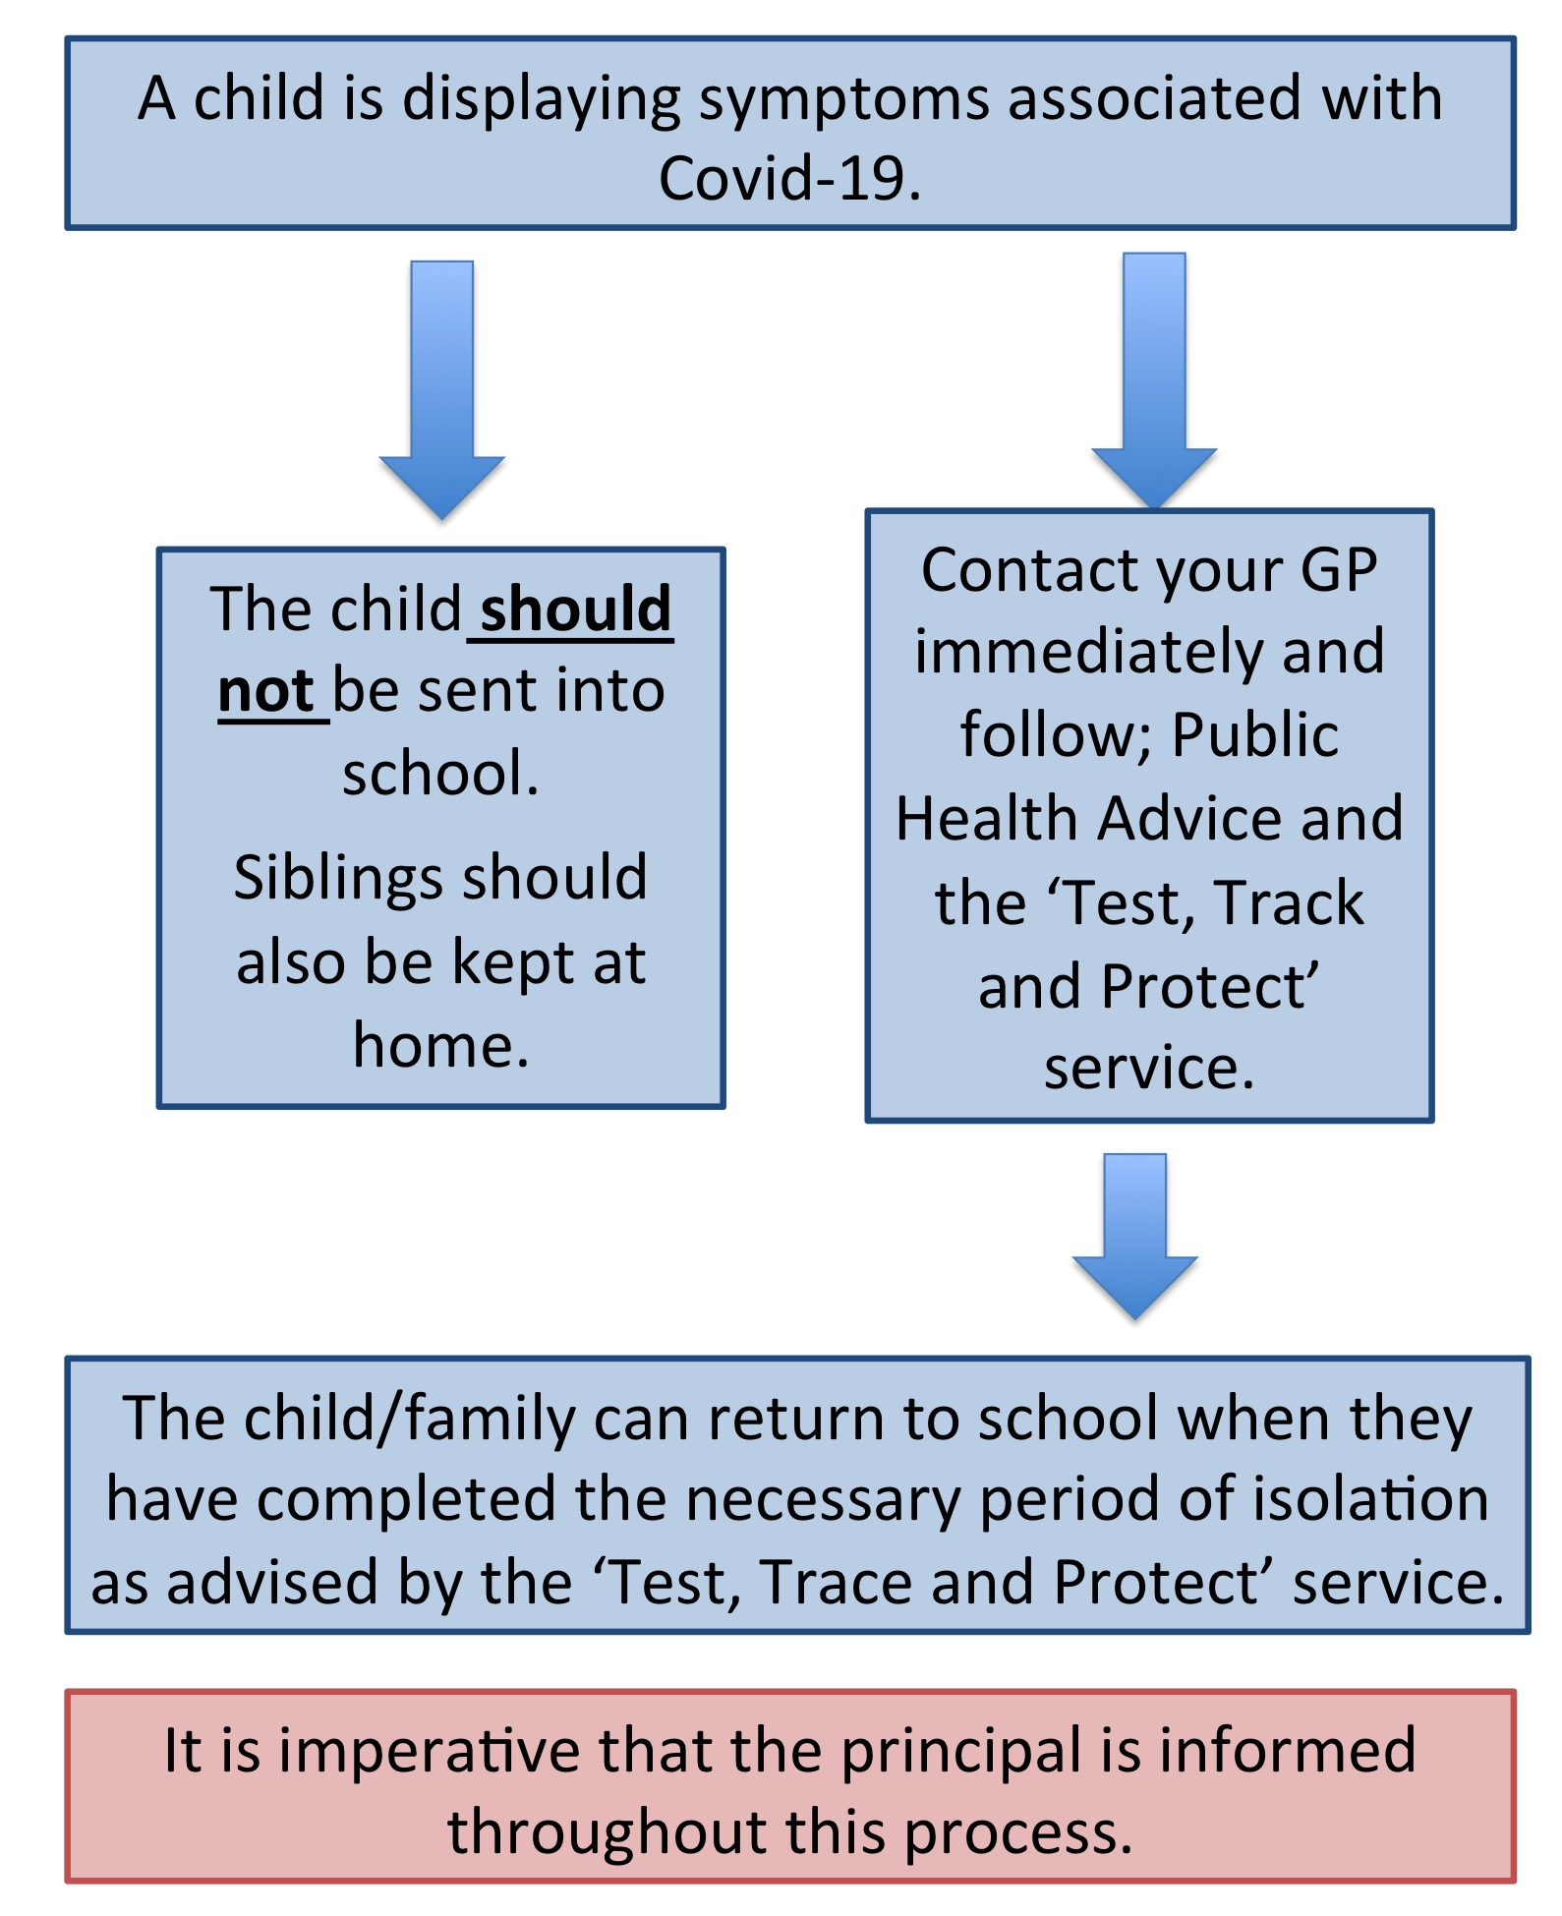
What happens if a child starts displaying symptoms?

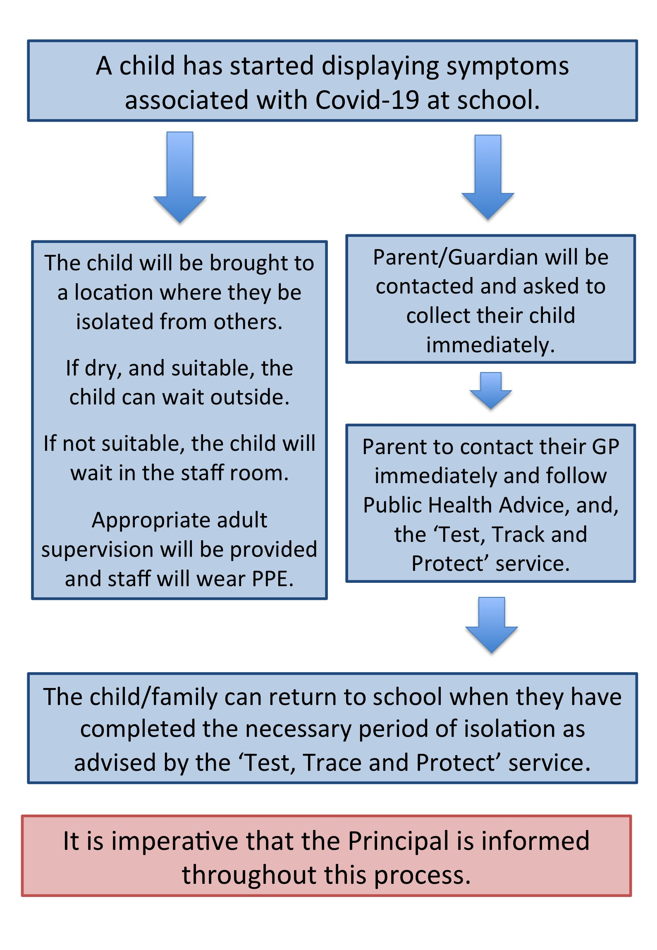

It is extremely important that the school has the parents/guardians most up to date contact details and are aware of the best number to contact first.
The child will be brought to a location where they be isolated from others.

If dry, and suitable, the child can wait outside.

If not suitable, the child will wait in the spare classroom.

Appropriate adult supervision will be provided and staff will wear PPE.
As you can appreciate, if your child displays symptoms, they should be collected immediately.

What happens if someone tests positive for Covid-19?
All families will be notified through the School App system.
All families will be notified through the School App system.
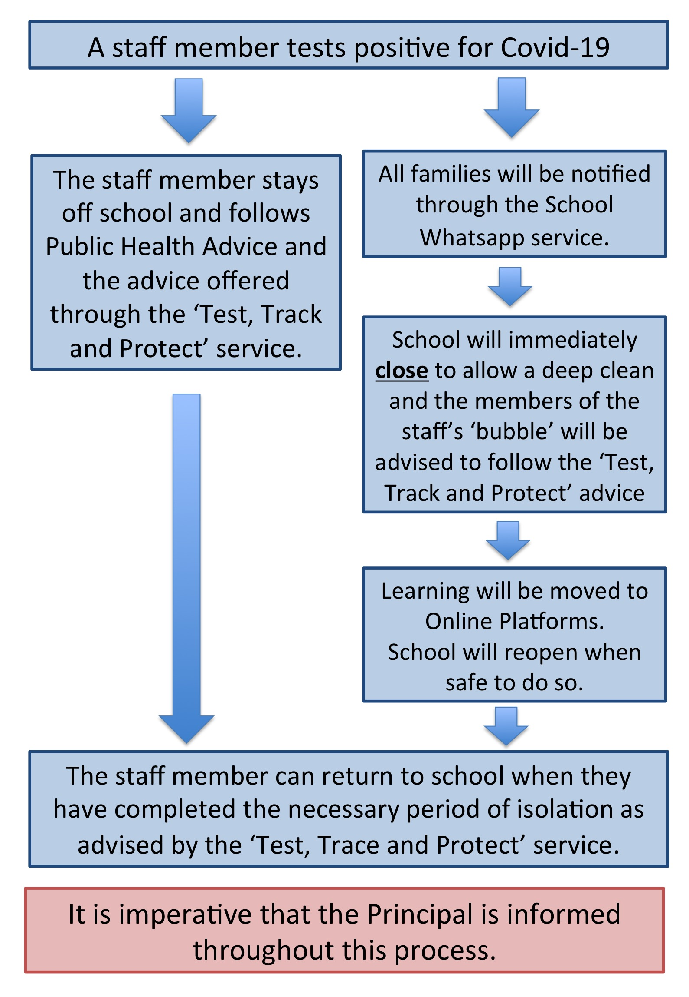
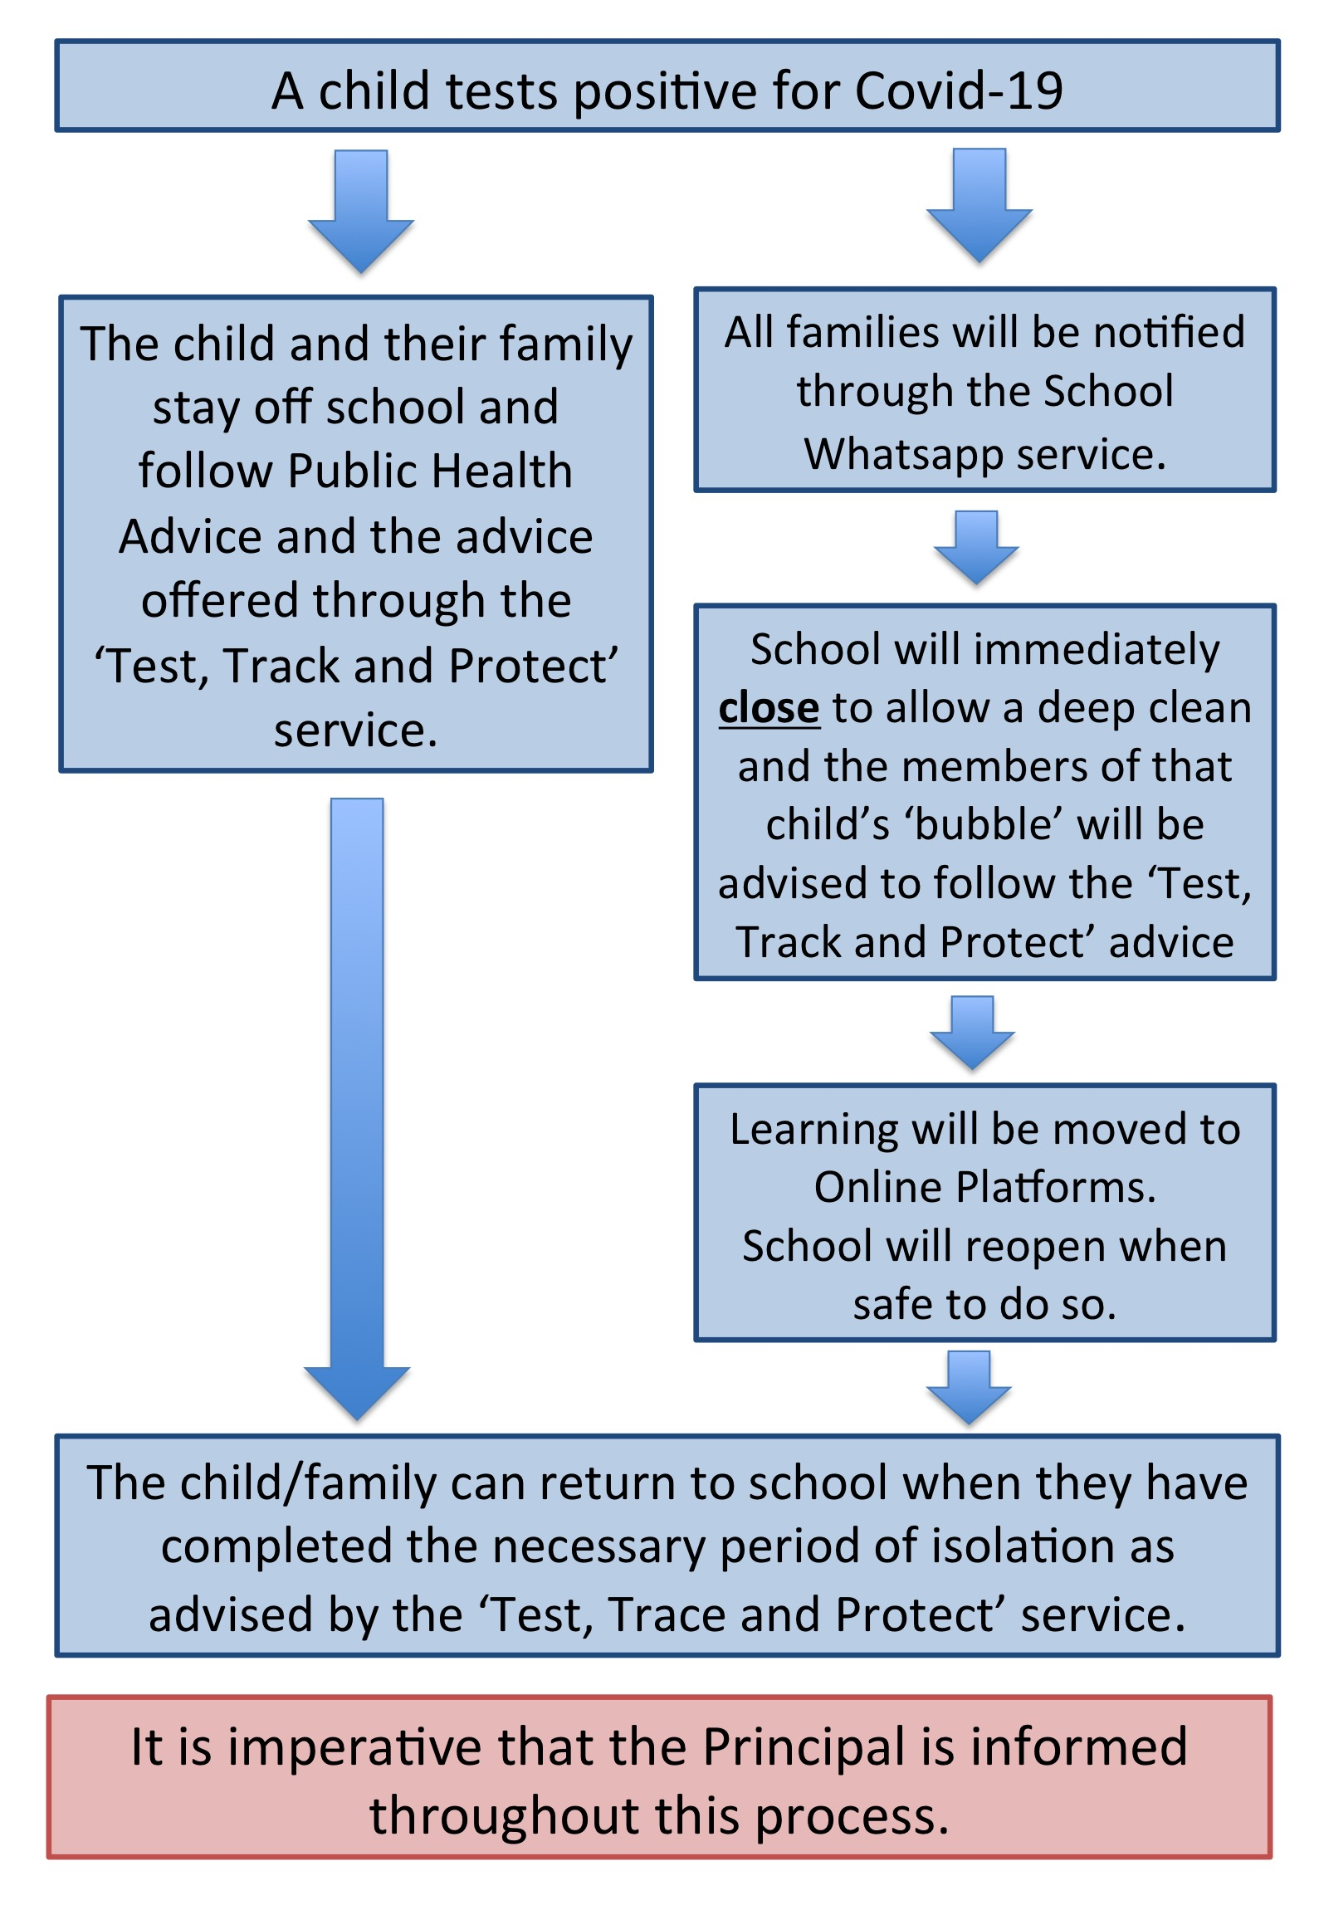

What has changed in school
To help maintain social distancing, our school, and classrooms, have been reorganised to utilise all available space and ensure children can return to as safe an environment as possible. The layout of the classroom will be slightly different compared to previous years. Children will have their own allocated seat and desk, which they will use throughout the school day.

Class Groupings
The class groupings for the start of this school year are:

P1 | P2 & 3 | P4 & P5 | P6&7
Mrs McGeough | Mr Carville | Mrs McFerran | *Mr Reel  Mr McCrory

*in order to facilitate Mr McCrory to manage the safe return of school, Mr Reel will be teaching P6/7 for the first half term and two days per week thereafter. This will allow for fluidity, maximum face to face teacher pupil time and minimum disruption to class time.

The children are organised into these groups, alternatively known as ‘bubbles’.

To help prevent the possible spread of the virus each bubble will:
- Stay as a group throughout the day and have limited interaction with other bubbles;
- Where possible, have the same adult(s) for the entirety of the school day.

What Children Need

Resources for School (these will stay in School)
In the pencil case (labelled with your child’s name) should be the following:

Primary 1 and Primary 2

• 1 pack of at least 5 writing pencils
• 1 small set of markers
• 1 small set of crayons
• 1 small set of colouring pencils
• 2 rubbers
• 1 large pritt stick glue (no coloured glue sticks please)

Primary 3 to Primary 7

1 pack of at least 5 writing pencils
• 1 small set of markers
• 1 small set of crayons
• 1 small set of colouring pencils
• 2 rubbers
• 1 ruler
• 1 highlighter
• 1 large pritt stick glue (no coloured glue sticks please)

All children will need:
- water bottle for a drink (named) – this can be reusable or disposable.
- 6 small packets of tissues
- 2 bottles of Hand Sanitiser

It is essential all items including school uniforms are clearly labelled with pupil’s name and class.

Due to CV19 we have been advised that RESOURCES MUST NOT be shared.

All these items will remain in school, and children will not be allowed to borrow/share belongings. We recommend that you have a similar pencil case which stays at home for homework.

Children are encouraged to wear a clean, fresh uniform every day and a coat is permitted. At present, no school bags are allowed in school. If needed, the school will provide every child with a plastic folder, which can be easily wiped down, to transport any learning materials to and from school.

Home - School Communication

This year we will be continuing with our normal methods to communicate with parents/ guardians to ensure that everyone is kept up to date with school events.

- School NI App
Please ensure that you have downloaded the School NI App to your phone and that you are linked to Foley PS.
- School Website
The school website will be regularly updated with news, upcoming events and important messages.
- WhatsApp
Sometimes it is easier to send a specific message to particular classes. Please ensure that we have your current mobile phone number.

Appointments with Principal and/or Teachers

In Foley PS, we pride ourselves on our relationship between staff and parents and encourage parents to contact us if there are any issues. This will continue to be the way, but, unfortunately due to social distancing restrictions, parents must make an appointment before visiting the school. This will allow staff to make arrangements to find a suitable and safe location.

You can make an appointment by ringing the school on 028 37531564. Please note that queries via the school’s social media account may not be responded to.

The Start of A School Day

Leaving Home

Before leaving for school in the morning, children should wash their hands thoroughly.

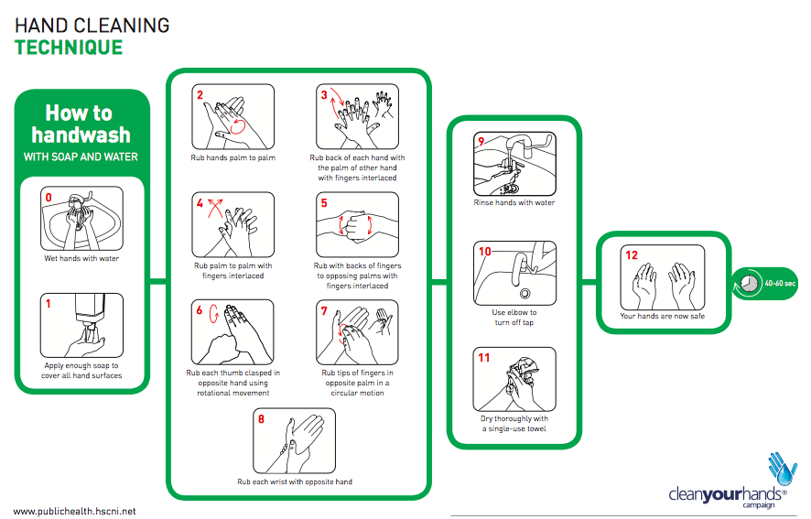

Arriving at school

In order to reduce the number of families and children arriving to school at the one time, and to follow the Department of Education’s guidance, we will be staggering arrival times. School gates will open at 8.45am and children have been divided into two groups according to alphabetical order. Group 1 will be permitted at 8.45am and Group 2 at 8.55am with lessons beginning at the new time of 9:00am.
Group 1 – 8.45am | Group 2 – 8.55am
Families with surname beginning A-L | Families with surname beginning M-Z

If there is an issue with the Group your child(ren) is in, please contact Mr McCrory as soon as possible. A staff member will be on hand to direct the children. Parents of children in Foundation Stage P1/P2 may come with the child to the entrance of the classroom and leave their child there. Parents of children in classes P3 - P7 should leave their children at the school gate and the children must walk to their classrooms in single file entering via the break out doors of each classroom.

Entering the school

Class | Entry point to school
Primary 1 | Playground, through small gate
Primary 2/3 | Playground, through small gate
Primary 4/5 | Playground, via big gate at main entrance
Primary 6/7 | Playground, via gate at principal’s office from post-box gate

When children arrive at school they should enter through the gate which is signposted for their class. Children should use the hand sanitiser provided at the gate and then proceed straight to their classroom.

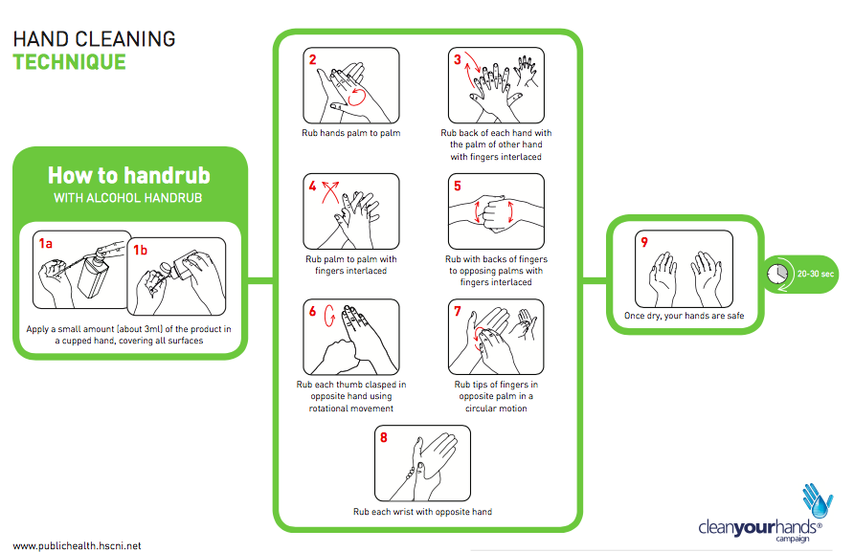

Whilst hand sanitiser will be available throughout the school, children are encouraged to have their own.

During the School Day

Despite the changes highlighted throughout this document, our aim is to make school as ‘normal’ as possible.

Toilets
All classes must use and access the toilets assigned to their respective classrooms only.

Toilets will be cleaned throughout the day especially after breaks and lunch, paying attention to taps, handles and toilet seats.

Children will be encouraged to only use toilets during ‘designated times’, for example before break and lunch, however, we are aware that this cannot always be controlled. Staff will be mindful not to send more than one child to the toilet at the same time, the only exception to this is for hand washing times and if supervised.

If a child needs to go to the toilet during break or lunch time, they will access the toilets directly using the external door and will be supervised accordingly.

Break and Lunch Times

To limit the interaction between ‘bubbles’, the Department of Education recommend that schools should stagger their break and lunch times. Taking this into account, this is what our ‘new’ school day will look like.

 | 8:45an – 8:55am | 9.00-10.00am | 10.00-10.15am | 10.15-10.30am | 10.30-10.45am | 10.45-11.00am | 11.00-11.15pm | 12.00-12.45pm | 12.30-1.15pm | 1.00-1.45pm | 12.45-1.00pm | 1.00-1.15pm | 1.30-1.45pm | 1.45-2.00pm | 2.45-300pm
P1
P2
P3
P4/5
P6/7
 | Arrival or departure from school
 | Break time
 | Lunch time

School Meals
For the week beginning 24th August, no school meals will be provided. All children should bring a packed lunch in disposable packaging. Packed lunches will be eaten in the classroom and therefore children will remain in their protective ‘bubbles’. From the 2nd September there will be a hot meal option available in the canteen as normal. The cost of dinner remains at £2.60. There will only be one choice of dinner for the first two weeks, this will be reviewed thereafter. A dinner menu will be provided as soon as we are given one.

If your child brings a packed lunch from home, it is preferable this is brought to school in a disposable paper bag which will be binned in school (this includes drinks – non fizzy) and a disposable spoon for yogurts.

Break time – as per school policy on healthy break – no chocolate/sweets or fizzy drinks are permitted at breaks.
- Break should consist of a healthy snack and a drink of water.
- In an effort to boost our healthy breaks we are offering a healthy break option to all children in our school.
- Healthy break will consist of fruit, crackers and cheese each day – the cost of this healthy snack is £15 per child/£25 per family per half term.

Collection Procedures

As with school arrivals, collection and departure procedures at the end of the school day will also be staggered.

Children will leave school through the same gate that they entered.

P1 parents have been notified of their times for the first week and thereafter.
P2 will finish at 2pm. With staggered collection times.
Group1 children will leave school at 1.50pm.
Group 2 children will leave school at 2.00pm.
To facilitate the staggered collection of P3-P7 children.
Group 1 children will leave school at 2.50pm.
Group 2 children will leave school at 3.00pm.

Late Pick-Ups

In order to ensure the success of the new procedures, we ask that parents are prompt in their arrival for the allocated time. If for whatever reason this is not possible, we would ask that parents contact the school office as soon as possible to notify the school of a late pick up.
In this instance a child would remain outside within their bubble where possible or they will be taken back to their classes, while we wait for the child’s parents to arrive.

WHAT YOU CAN DO AT HOME TO HELP WITH THE TRANSITION BACK TO SCHOOL

- Talk positively to your child about restarting school
- Use a calendar to start the countdown for going back to school
- Get your child back into the school routine i.e. get to bed earlier, show them the school uniform, have a good morning routine
- Read books with your child at home
- Prepare their school uniform and have it in their bedroom for them to see
- Remind them of all the fun things they do in school e.g. see friends from their class, play outside, draw, paint etc
- Drive past school and remind your child of the journey they will take each morning
- Ask them to talk about three happy memories of school
- Explain to the children there will be changes in how the school operates eg play time, lunch time etc
- Ensure your child knows how to wash their hands thoroughly

PUPIL CONDUCT AND WELLBEING

The school’s usual Behaviour Policy and rules for pupils are still relevant in the new school scenario, however, there are additional rules and routines pupils must now be aware of and follow. Any pupil unable to follow the school’s current and amended rules will be unable to attend the school setting.
- Pupil wellbeing is paramount during their time in school.
- Children will be anxious over having missed school and their friends, ongoing news about the virus, bereavements and more.
- Part of the children’s curriculum will focus on promoting good mental health, providing time to discuss their worries and concerns.
- Immediate or evolving pastoral concerns should be forward to the Designated Teacher for Safeguarding – Mr Carville or Deputy Designated Teacher for Safeguarding – Mrs McGeough.

ADDITIONAL BEHAVIOURS PERTINENT TO COVID-19 AND SOCIAL DISTANCING

In line with DE’s guidance, if a child’s behaviour is deemed high risk, for example, refusing to adhere to safety measures, such as, hand washing, appropriate social distancing, remaining in their classroom or deliberate behaviours that put themselves or others at risk, such as spitting or deliberately coughing at others, the following sanctions and disciplinary procedures could be used:
1. Referral to Principal
2. Parents/Carers called to collect child from school immediately
3. Immediate switch from onsite education offer to online/virtual education offer for a period decided by the Principal.
4. Suspension
5. Permanent exclusion

CONTACT AND MIXING
- The interaction between classes will be kept to a minimum.
- Lines and markings will be ruled in the school and posters will be on display around the school visibly emphasising the need for social distancing and handwashing.
- Desks will be forward facing.
- Rules will be clearly discussed and displayed and staff will explain the new rules for movement around the classroom and maintaining appropriate social distancing. The pupils will be constantly reminded of the rules.
- Staff are required to maintain appropriate levels of social distancing from other adults in school and following the most up-to-date guidance on interacting safely with children.
- No more than one girl and one boy from each class may use the bathroom at the same time.
- Children should only move around the school when absolutely necessary.
- Clear procedures including a staggered starting/end times are in place.
- Maintenance officers and workmen will be admitted via the main entrance and will report to the Caretaker.
- Clear guidelines are in place for parents and visitors entering the school.
- Dropping off, collection, break and lunchtime are staggered to reduce contact.
- As far as possible children will only mix with their own class group.

EQUIPMENT & UNIFORM

Initially, children will NOT need to bring a school bag or lunch box with them to school each day (as per Department of Education Guidance August 2020). This will be reviewed in due course.

As per previous correspondence and in accordance with school uniform policy, children will wear their usual school uniform each day but can alternate to PE uniform on a Tuesday and Thursday. We will timetable all PE lessons for these days as far as possible.

ENHANCED CLEANING & HYGIENE IN SCHOOL

We take great pride in the appearance and cleanliness of our building. I am most grateful to our caretaking and cleaning staff in maintaining this high standard. Due to Coronavirus there will be an enhanced cleaning regime in school and windows will be opened to ensure a healthy circulation of air in classrooms.
Following guidance “Guidance to support safe Working in Educational Settings in Northern Ireland”, children SHOULD NOT wear PPE (Personal Protective Equipment) e.g. face masks or face shields in school, this may be reviewed in the coming weeks/months.

Homework
Currently school is considering how homework will operate (in line with DE guidance). Further information will be provided on this. There will be no homework for the month of September.

School Closure (Partial/Whole School)
There may be an occasion that a class, year group or whole school will be required to close due to CV 19. This will be done after consultation with PHA and EA. If this is the case the school will endeavour to switch to the blended learning approach or the online approach. This option will be a last resort.
There may also be times when a class is asked to stay at home if we are having difficulties with teacher cover due to CV19. As a school we will keep you up to date via email/text etc. We would ask you to work in partnership with us should this be the case. In line with DE Guidance if there is a positive case within a class that classroom must be closed for a minimum of 4 days.

OTHER HEALTH & SAFETY MATTERS

The School has undertaken Risk Assessments and put together routines and procedures which we believe will provide effective protection. In addition, some advice from the Public Health Agency is set out below:

1. Minimise contact with individuals who are unwell by ensuring those who have coronavirus (COVID-19 symptoms) or who have someone in their household who does DO NOT ATTEND SCHOOL for a period of no less than 14 days.
2. Washing hands thoroughly for 20 seconds with running water and soap or using alcohol hand sanitiser will be an integral part of the everyday routine.
3. Ensuring good respiratory hygiene by promoting “Catch It, Bin It, Kill It” approach.
4. Cleaning frequently touched surfaces using standard products such as detergents and bleach.
5. Minimising contact and mixing bubbles by altering the environment (such as classroom layout) and timetables (staggered break/lunch times).

I must emphasise the importance to parents in following the guidance in point 1 and ask that you are vigilant in keeping your child at home if he/she feels unwell. It is crucial that you inform the school in the event of any person in your household being diagnosed with Coronavirus.
The arrangements outlined in this document may indeed change considerably over time.

CORONAVIRUS HOME/SCHOOL AGREEMENT:

As a school we will try to do our best to:

- Provide an environment which has been risk assessed in response to the COVID-19 infection;

- Adhere to the social distancing rules as set out by the government as much as we reasonably can;

- Provide a curriculum that meets the needs of your child’s well-being, mental health and academic needs;

- Contact parents/carers if your child displays symptoms of COVID-19

- Inform you if staff or children in your child’s ‘bubble’ show symptoms of COVID-19 as this

- will mean you will all need to self-isolate for at least 14 days or until the test comes back negative;

- Continue our clear and consistent approach to rewards and sanctions for children as set out in the school Behaviour Policy

- Communicate between home and school through text messages, email and the school app

Parents we ask you to adhere to the following:

- If your child, or anyone in my household, shows symptoms of COVID-19, you will not send them to school, you will self-isolate for 14 days as a family, you will get them tested and you will let the school know as soon as possible via telephone;

- If your child, or another child in the group, shows symptoms of COVID-19 at school, you will collect your child from school immediately;

- On your commute, and when dropping your child off and picking them up, you will adhere to the 2 metre social distancing rules.

- When dropping off and picking up, you will strictly stick to the school timings for your child;

- Your child must not bring any items into school with them or take items home from school

- Your child will have their temperature taken before going to school by a you the parent or career.

- You will need to remind your child about social distancing rules. They may find this difficult but you will need to encourage them and demonstrate how to do this in a positive way.

- Your child will use good respiratory and hand hygiene;

- You will not be allowed into the school without a pre- arranged appointment – you can make appointments via telephone or email;

- You will support all staff in their efforts to create an ‘as safe as possible’ environment during this pandemic;

- You will read all letters/messages/emails that are sent home;

- You need to inform the school immediately of any changes to parents/career and emergency contacts details.

- If your child is deemed unsafe, you know he/she will be sent home and cannot return to school until it is safe to do so.

- If your child is feeling unwell please do not send them to school. You will be called for straight away to come and collect them.

- At present we are not checking temperatures on arrival at school. In the event of children being sent to school feeling unwell or displaying a temperature – we will begin temperature checks at school gate, any child with a temperature will be refused access to school.

Children we ask you to:
(parents we ask you to discuss these rules with your children)

- Keep a safe distance from others

- Tell an adult if you feel unwell

- Only use the equipment provided to you by school and no other;

- Follow good respiratory hygiene: coughing and sneezing into elbow or tissue (catch it-bin it-kill it);

- Follow good hand hygiene – washing hands using soap and water for 20 seconds/ hand sanitizer;

- Behave well at all times to maintain the safety of myself and others;

