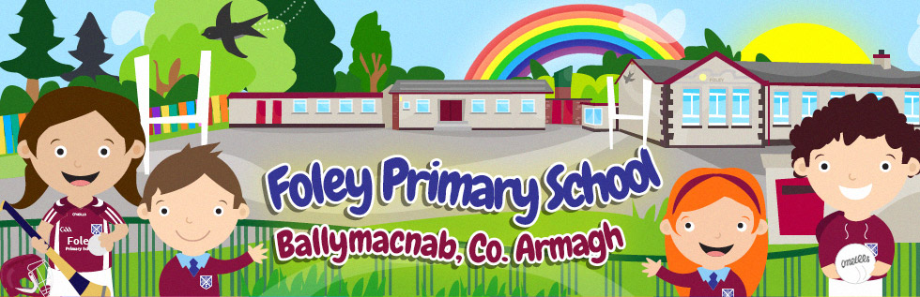

After Schools Sports Club
Dear Parents/Guardians
We are delighted to be able to offer After school’s sports club to the children for the next 5 weeks. Each class will have one club per week. Please see table below.

Class/ Club | Sports club
P1/2 | Monday 2.00pm-3.00pm
P3/4 | Wednesday 3.00pm – 4.00pm
P5/6/7 | Thursday 3.00pm – 4.00pm

If you would like your child to attend, please click the link below and fill out the form.

https://forms.office.com/Pages/ResponsePage.aspx?id=-yeCOETeDkaBkAVAK4mNqDyOtQGCB9BDt9ddO4kmQCRUNE0yTzMwSEtTTUVCQzhQVlhFUFQwVkMzUy4u

Kind Regards,

Kieran McCrory

