15th March 2020

Dear Parents,
The announcements from the Government over the last few days has instructed all schools in Northern Ireland to remain open. We have no choice other than to follow this advice, but as a Parent myself I completely understand your worries and fears for your children and families. Some Parents have already made the decision to keep their children at home and this is your right to do so should you believe it is the correct decision for your family.

With Confirmation already postponed, it is most likely this will extend to First Confession and possibly First Holy Communion.

During this period we wish to limit visitors to school.
- Parents/visitors are not permitted beyond the secretarys office and should not enter classrooms.
- Our Mothers Day Tea Party and all other school events are cancelled until further notice.

However, it is widely believed that the Government will close schools soon so we have put a plan into place for your children if you choose to keep them at home or should the Government decide to close schools.

Class teachers have prepared a work pack for each child. We suggest the following work should be done with your child at home if they are off school:

Primary 1 and 2

- All children will be sent home a literacy and Numeracy booklet, we recommend completing at least 2-3 pages of each booklet per day.
- Work on their Phonics and encourage them to write simple sentences.
- Jigsaws, board games and painting/arts and craft will be a great way to pass time and will keep minds active.
- Work on number stories. There are lots of games and ideas online to help your child learn these important number facts.
- In a bid to avoid any possible contamination, reading books will not be sent home. Your child is set up with a username and password for studyladder.co.uk This is in your homework pack. There are some word and reading activities assigned and you can work through them with your child. (Studyladder link available on School Website under ‘Home Link’)

Primary 3 and 4:
- All children will be sent home a literacy and Numeracy booklet, we recommend completing at least 2-3 pages of each booklet per day.
- P3 – Numeracy: Explore numbers to 100 e.g. numbers before/after/between, ordering, adding 10, doubles to10+10
- P4 – Numeracy: explore numbers to 999, number before/after/between, ordering, 2x 5x 10x tables practice
- P3/4 Literacy: Read books, make a book, practice handwriting.
- In a bid to avoid any possible contamination, reading books will not be sent home. Your child is set up with a username and password for studyladder.co.uk This is in your homework pack. This will replace guided reading for the duration of this time, please read the comprehensions with your child and let them answer the questions. We recommend completing at least 4 of the comprehension activities each week. (Studyladder link available on School Website under ‘Home Link’)

Primary 5 – 7:
- All cildren will be sent home a Literacy and Numeracy booklet, we recommend that each child complete at least one page of each booklet per day.
- In a bid to avoid any possible contamination, reading books will not be sent home. Your child is set up with a username and password for studyladder.co.uk This is in your homework pack. This will replace guided reading for the duration of this time, please read the comprehensions with your child and let them answer the questions. We recommend completing at least 4 of the comprehension activities each week. (Studyladder link available on School Website under ‘Home Link’)
- Writing more detailed stories and recounts.
- Reinforcement of Times Tables/ Number Facts will be invaluable.

I have added a new ‘Home Link’ to our school Website, this is available under the Parent tab. There are also some links for fun and interactive games that are all age appropiate.
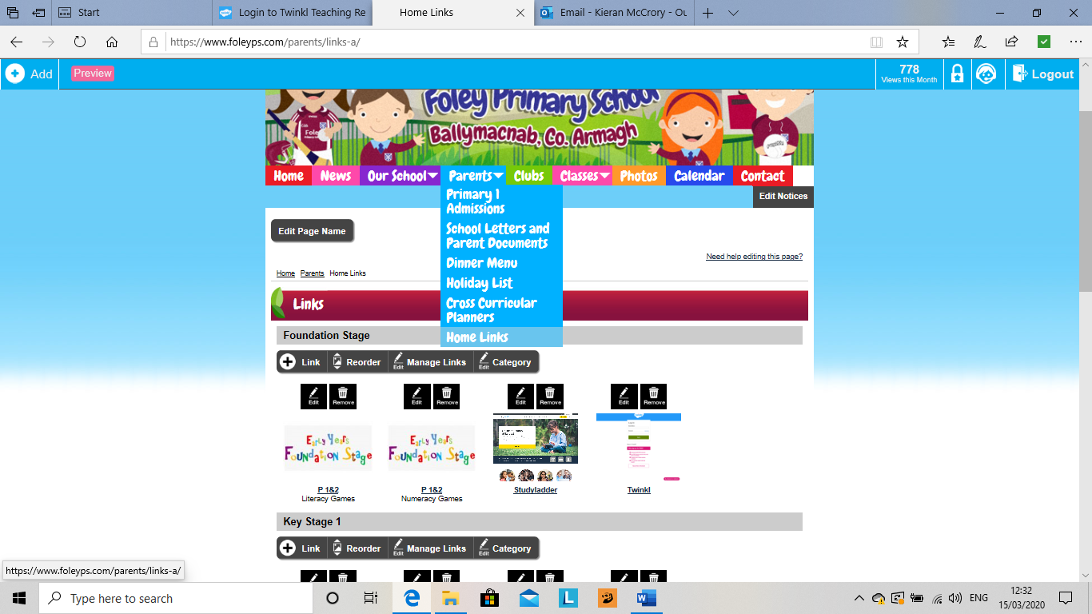

Twinkl have offered free access to all of their resources for the next month, all each parent has to do to access this resource, is set up an account if they wish. The link is on the school ‘Home Link’ page.

Please remember that in a bid to avoid any contamination, all homework packs are not to be returned to school.

In the event of our school closing we will keep you informed through our website, Facebook page and WhatsApp service.

With prayer and time, Please God, this will pass and we will be back to our full school life with our amazing children.

Please don’t hesitate to contact me with any questions or concerns and I will do my best to help.

I will be in school on Wednesday morning regardless of any announcements that are made in the interim. If it is announced that schools are closed, homework packs can be lifted between 8:30am and 10:30 am.

Yours Sincerely

Kieran McCrory

Principal

